Golf Managers Association of New Zealand
Warren Collett Life Member

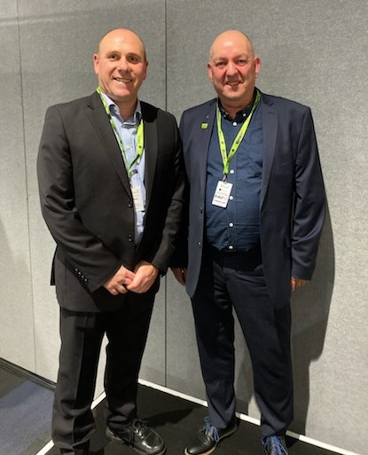

L to R
Chris Davies President Golf Managers Association, Warren Collett CCM

In recognition of many years of hard work and commitment to the Golf Managers Association of New Zealand Association, President Chris Davies took great pleasure in awarding Life Membership of the Association to Warren Collett CCM. Highlights of Warren’s achievements over 25 plus years included implementing paid staff to administer the Association and setting in motion, in conjunction with Club Management of America, the BMI educational programme, a first for Australasia, which has produced 7 CCM qualified personnel including himself to date.

Warren’s life membership was presented at the GMANZ/NZGCSA Summit and Fine Turf Seminar dinner held in Auckland recently and he joins Russell Hill retired GM The Grange Golf Club as the sole Life Members of the Association.

Thank you to our sponsors.

Principal Sponsor



Major sponsors








Exclusive beer supplier

 | 
 | 
 |  | 
 | 
 |  | 

