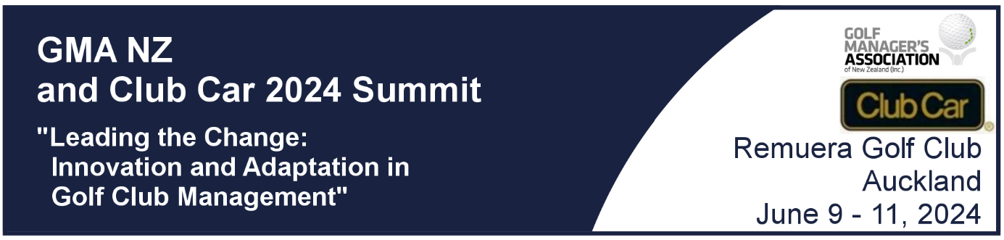

Golf Managers Association of New Zealand
Club Car Summit
Auckland
June 9-11, 2024

Leading the Change: Innovation and Adaptation in
Golf Management"

Programme




Our Purpose
The annual Summit of the Golf Club Managers Association is designed to bring together the diverse and dynamic golf industry leaders in our country to share their thoughts and ideas on developing strategies that will help grow golf club business.

This Summit is a great opportunity for us to learn from each other, share best practices, network with peers, and celebrate our achievements. We have a packed two-day agenda, featuring keynote speakers, panel discussions, workshops, and social events. You will also have a chance to visit the trade show, where you can discover the latest products and services from our partners.

Our theme for this year is "Leading the Change: Innovation and Adaptation in Golf Management". As you all know, the golf industry is facing many challenges and opportunities in the current environment, such as financial pressures, changing consumer preferences, environmental sustainability, digital transformation, and diversity and inclusion. We need to be proactive and creative in finding solutions and embracing new possibilities. That's why we have invited some of the most influential and inspiring leaders and experts from within and outside the golf sector to share their insights and experiences with us.

We invite you to enjoy this Summit. You will find it valuable and rewarding. I encourage you to participate actively, ask questions, exchange ideas, and make new connections. I also invite you to share your feedback and suggestions with us, so we can continue to improve and grow as an association and as an industry.

Thank you for your support.
Richard Nauck
Chairman
Golf Managers Association of New Zealand

Programme

Day one

Sunday 9 June 2024
4.00pm | Club Car Virtual Golf Competition.  Event managed by Remuera Golf Club  Longest drive, closest to the pin, teams’ competition
5.30pm | Prizegiving and refreshments
6.00pm – 7.30pm | Trade show opens.  Mix and Mingle - networking

Day two

Monday 10 June 2024
7.30 am | Registration desk opens
7.30am | Trade show opens
8.00am | MC  Ross Bond GM Shandon Golf Club  “Setting the scene”
8.00am - 8.10am | Opening addresses  Richard Nauck PGA CCM  Chair GMA NZ
8.10 am – 9.15 am | Gregg Patterson  Founder, President Tribal Magic  “Developing the Team”
9.15am – 10.00am | Jeff Latch  CEO Golf NZ
10.00am- 10.45am | Dean Murphy  CEO Dot Golf Ltd
10.45 am – 11.15am | Morning tea and trade show visits
11.15 am – 12.30 pm | Sacha Coburn  COO - Coffee Culture  Board member - Tieke Golf Club  “Optimizing the role of the board: avoiding sand traps, staying out of the rough and never losing your balls.”
12.30 pm – 1.30 pm | Lunch and trade show visits
1.30 pm – 2.30 pm | Dr Jason Koenigsfeld PhD, CHE  Senior Vice President, Professional Development,  Club Management Association of America
2.30pm – 3.00pm | Afternoon tea and trade show visits
3.00pm – 4.00pm | Mat Wylie  CEO/Founder Customer Radar / Entrepreneur / Speaker  “My experience and thoughts on reputation management and customer/member feedback.”
4.00 pm – 5.00 pm | Panel discussions - details below
5.30 pm – 6.30 pm | Hospitality Hour and trade show visits
7.00 pm | GMA NZ Summit Club Car Dinner
8.30 pm | GMA NZ Club Car Club Manager of the Year Award
8.40 pm | Guest speaker  Gregg Patterson  Founder, President Tribal Magic
11.00 pm | Close

Industry Panel discussions
4.00 pm - 4.30pm | “Ensuring your insurance coverage is adequate.” | Scott Steward - GM Napier Golf Club  Warren Collett - GM Ops Wairakei GC  John Woodham – CEO Power Turf NZ
4.30pm - 5.00pm | “Dismantling club membership options. Are entrance fees and minimal membership categories relevant today” | Chris Davies GM Remuera Golf Club
5.00pm-  5.30pm | TBA

Day two

Tuesday 11 June 2024
7.30am | Registration desk opens
7.30am | Trade show opens
8.15am – 9.15 am | Ed Chapman  CEO Royal Auckland and Grange Golf Club  Mark Hooker  Director of Agronomy Royal Auckland and Grange Golf Club Inc.  “Technological advancements in our industry”
9.15am – 10.15am | Michael Rondel  Partner BDO Christchurch  Kerry Topp  The Kerry Topp Collective  “How to understand and thrive from the long-term effects of the COVID-19 era on the golf industry”
10.30am – 11.15 am | Morning tea
11.15 am – 12.00 pm | Suzie Johnson RN  The Best speaker - Registered Nurse - Life Coach  Rated No 1 speaker at the Golf Matters Conference in 2022, Suzie’s back by popular demand!!  “Change is the only certainty of life”
12.00 pm – 1.00 pm | Lunch
1.00 pm – 2.00 pm | Liz Perkins  Hospitality Business Coach  Perkins Coaching  “Using your customer data to improve your team's engagement.”
2.00pm – 2.15pm | Afternoon tea
2.15pm – 3.30pm | New Tech Innovation  Presentations & Q&A’s from representatives from:  - Northstar  - Dot Golf  - Golf Genius  - Mi Club
3.30pm – 4.15pm | Gregg Patterson  Founder, President Tribal Magic  “When love ain’t enough.”
4.15 – 4.20pm | Closing speech

Our keynote speakers
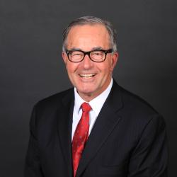

Gregg Patterson
Founder, President Tribal Magic

Often referred to as the “club sage” or the “club oracle,” Gregg, the long-time general manager of The Beach Club in California, is set to take the stage at the Club Car GMA NZ Summit to be held at the Remuera Golf Club from June 9-11, 2024. He is known for his charismatic personality and his ability to provide brilliant management solutions to virtually every challenge in the club industry. At the Club Car GMA NZ Summit, he will tackle the battle of addressing today’s multi-generational demographics and provide a roadmap on how to make clubs relevant to the differing needs and priorities of a diverse population¹.
Gregg believes that people today want more “buzz,” more memories, and more experiences per minute invested and dollar spent. He says that people are drawn to leisure pursuits that are quicker to master and less challenging to enjoy, as lives are filled with “more” and schedules are packed to overflowing. Time is precious¹.
According to Gregg, family is job one, and when decisions are made, kids come first. Wives are more vocal, emotionally stronger, better educated, business-savvy, and confident, and they want a say in decision-making before time is spent or dollars invested.
Gregg also believes that conspicuous consumption is out, and conspicuous virtue is in. The younger generation doesn’t need a badge and is turning from “club” to find status in other things in other places. The competition “out there” in the marketplace has become meaner, more aggressive, niche-oriented, uber-competitive, and fast to adapt¹.
It is clear that Gregg is a futurist in his own right and is not someone who will walk away from a fight. He is a living, breathing war-chest of brilliant management solutions to virtually every challenge large or small in the club industry.

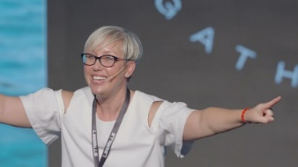
Sacha Coburn
COO - Coffee Culture
Board member - Tieke Golf Club
Sacha Coburn, a distinguished leader and motivational expert, brings an exceptional blend of experience and insight to any speaking engagement.
As the Chief Operating Officer of Coffee Culture, Sacha has proven her mettle in guiding her family business through the challenging landscapes of the pandemic, demonstrating resilience and an ability to thrive under pressure. Her entrepreneurial journey is complemented by her extensive experience in leadership development, notably through her venture, The Company You Keep, which offers immersive programmes and executive coaching.
A former lawyer with a Master’s Degree (First Class Honours) in Education, Sacha is also a graduate of the prestigious Owner President Management Program at Harvard Business School. This unique combination of legal, educational, and business acumen positions her as an expert in delivering impactful and engaging presentations.
Sacha’s speaking engagements are renowned for their energy, humour, and practical insights. Her keynotes are a blend of hard-hitting messages, vulnerability, authenticity, and humour; and appeal to a wide range of audiences. With a style that’s part concert, part musical journey, part stand-up comedy, and part sermon, she ensures every participant leaves inspired and uplifted.
Sacha Coburn focuses on leadership, high-performing teams, navigating change, and leading through challenging times. Her commitment to exploring the limits of what’s possible, makes her a dynamic and influential figure in any speaking engagement.
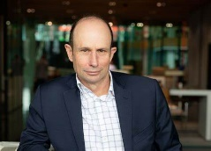

Jeff Latch
CEO - Golf NZ
Jeff is one of New Zealand’s leading executives in sports broadcasting. His background includes 30 years of experience in senior leadership roles, including at Spark Sport, Television NZ, Sports Inc and Touchdown Television.
In addition to his wealth of experience and strategic leadership skills, he also brings a vast national and international network in the sports and broadcasting industries and has a reputation for building trusting relationships with a wide variety of stakeholders.
Jeff is a passionate golfer and a member of Waitemata Golf Club. He understands the unique dynamics of membership-based sport and is connected with the golf community through his previous work, where Sportsinc produced various golf shows, such as The ING Golf Show, Golf World, and UBS Golf Club.
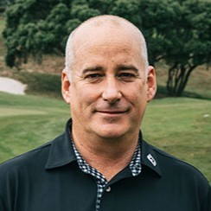

Dean Murphy
CEO – Dot Golf Ltd
Dean has been working in the golf industry for 16 years including 13 years as Chief Executive of Golf New Zealand. In August 2023, Dean was appointed by The R&A and Golf New Zealand to lead Dot Golf as its Chief Executive. Prior to working in the golf industry, Dean worked with Lion Nathan as a graduate, and then spent 10 years working in tourism industry in London.

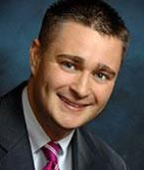

Jason Koenigsfeld PhD
Club Management of America
Senior Vice President of Professional Development

Jason is the Senior Vice President of Professional Development for the Club Management Association of America (CMAA). Jason has conducted numerous education sessions on topics including leadership, management competencies, management and delegation, organizational behaviour and change, membership marketing, communication, strategic planning and team development for the Club Managers Association of Southern Africa (CMASA), the Club Managers Association of Europe (CMAE), the China Chapter of CMAA, the Canadian Society of Club Managers (CSCM), The Private Club Alliance of Russia (PCA), Golf Managers of New Zealand (GMANZ), The Golf Managers Association of Australia (GMA), The Colombian/Peru and Ecuador Club Managers Association and for CMAA.
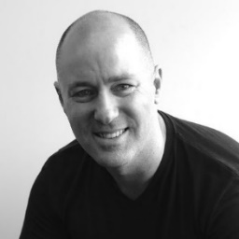
Mat Wylie
CEO/Founder Customer Radar
Entrepreneur / Speaker
Customer Radar is a live customer feedback and reputation management platform. Our mission is to make Customer Feedback software that’s easy, actionable, and insightful.
Customer Radar is designed to empower businesses and clubs through their frontline teams to manage their customer/member feedback, so they can retain more customers and continuously build their online reputation.
Customer Radar is used by enterprise clients and software partners to enable NPS feedback via single or multi-channel touchpoints. This enables our users to get feedback from their customers/members when they want, via touchpoints that suit their business.
Customer Radar makes it easy for our users to turn their feedback into marketing gold, by making it easy to share great feedback with the world, as well as continuously grow their online reviews via platforms like Google Reviews and Trip Advisor.
The platform has been developed over 10+ years through in market testing and continuous R&D with thousands of active users and sites. From some of the largest businesses in the territories, through to SMEs that get the benefit of enterprise level software.
Customer Radar can be used almost anywhere in the world. It can be plugged in to virtually any software platform, either as an add on directly or via API. It can stand alone or can be fully customised for enterprise businesses.
We’re helping businesses around the world grow faster, one happy customer at a time.
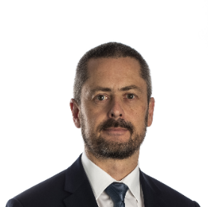

Michael Rondel
Partner – BDO – Christchurch
Board Member - Golf NZ

Michael helps lead the audit and assurance advisory division as a Partner at BDO Christchurch. He has extensive experience both in New Zealand and overseas in providing professional services to medium to large-sized corporate entities and is also involved with a large number of not-for-profit and public sector organizations. Michael has been involved at a governance level with a number of not-for-profit organisations - he is a former Chair/President of the Canterbury Golf Association and was Finance Director and Chair at the Harewood Golf Club for a number of years. He has recently been elected to the Board of Golf NZ. Michael is also a Trustee and Chair of the International Track & Field Trust (a charitable trust focused on developing pathways for youth into elite athletics). He has also been a facilitator for the finance sections of the CMA/GMANZ qualification for a number of years.

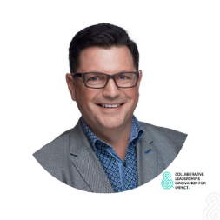
Kerry Topp
Managing Director - KDT Collective

“Helping courageous business leaders innovate & collaborate for intergenerational value, impact & relevance.”
Kerry Topp is the founder of The Kerry Topp Collective (The KTC), a boutique leadership and innovation practice. Specialising in aiding multi-sector organisations with turnovers ranging from $10m to $100m, The KTC is dedicated to accelerating strategy development and execution, as well as the delivery of new products, services, markets, and models for growth. Kerry brings an emphasis on incorporating cultural intelligence from a Pākehā perspective and is committed to aligning Boards and Executive teams, all while honouring the principles of Te Tiriti o Waitangi.
Kerry’s career history includes influential roles such as Associate Director of Transformation & Innovation, and prior to that, General Manager of Digital, Mobile & Innovation at Datacom, Distribution & Customer Solutions Manager at Air New Zealand and Senior Technical Programme Manager at TelstraClear from 2004 to 2005.
Kerry's approach is relationship-centred, fostering trust and respect. His mission consistently aims to enrich lives, with a clear purpose to ‘connect people & technology’ for the advancement of businesses and communities, and he aspires to leave a legacy as 'Good Ancestor.'

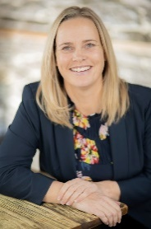

Liz Perkins Dip Hosp Management
Hospitality Business Coach
Perkins Coaching

With a background as a restaurant owner Liz is passionate about people and business. Business ownership is challenging and can be incredibly rewarding. In an industry that demands the best we must apply best practices to every element of our businesses to create and sustain profitable venues.
Liz provides outstanding hospitality business education for owners and employees and encourages meaningful action and follow through resulting in improved profits and personal development.
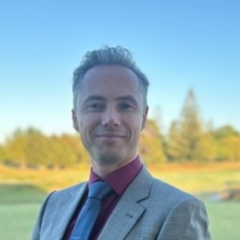
Ed Chapman
Chief Executive, Royal Auckland and Grange GC

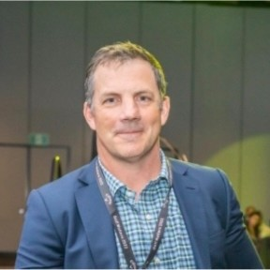
Mark Hooker
Director of Agronomy, Royal Auckland & Grange Golf Club Inc.

Our Summit partners.

Principal Partner



Platinum partners

Gold partners
 | 
Silver partners

 | 
 | 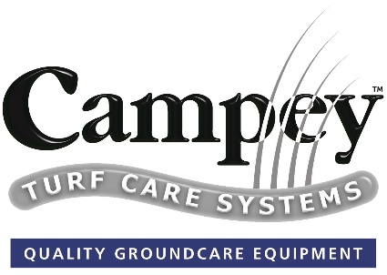
 | 

