
Golf Managers Association of New Zealand and Club Car Summit
Lower Hutt
August 27-28, 2023

“Partnering beyond the green”

Programme



Our Purpose
“Partnering beyond the green”
It is the obligation of the Golf Managers Association of New Zealand (GMA NZ) to provide the best outcomes for New Zealand’s Golf industry by bringing golf club managers together in a collaborative manner to discuss opportunities to grow the game.
Working in our own silos will not have the impact needed to survive in what is a highly competitive sporting-based environment. We need to be able to work together across both our sectors if we are going to have a real impact.
The secret about collaborating and cross sectoral work, is it requires us to work in new and different ways. It can be hard, and it requires us to give things up, or to renegotiate loyalties. It requires us to care about the things that our collaborators care about. But when it works, it can be powerful.
We think it is important that we share what we are learning. We are not great at collaboration in Aotearoa New Zealand and the challenges we need to navigate are going to force us to do more and more of it. So, if we are going to get better at it, let us learn from each other.
We look forward to sharing further details of the planned Summit as we progress our planning.

Richard Nauck PGA
President
GMA NZ

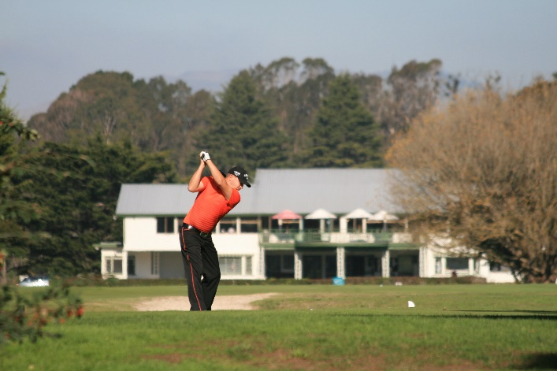

Organising committee:
Event Manager: Des Topp Executive Officer Golf Managers Association of New Zealand
Organizing Group: Amy Sidford GM Boulcott’s Farm Heritage Golf Club.

Location:
Lower Hutt

Venue:
Boulcott’s Farm Heritage Golf Club

Accommodation:

Sebel Hotel Lower Hutt - Accommodation to be booked by delegates direct.

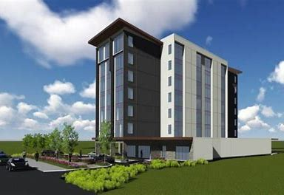
The Sebel Lower Hutt, as the preferred accommodation supplier, provides a 15% dynamic rate code for the Summit dates. The 15% dynamic rate code discount can be actioned by Summit delegates by directly booking from our hotel website.
GMA NZ Summit 2023 - Accor Meetings & Events (accorevents.com)

Please note: The room rates are dynamic in nature, 15% discount will be applied to the rates at the time of you making the reservation. Breakfast is extra.

Programme

Day 1 Sunday 27 August 2023
Summit Golf Day
Event managed by Boulcott’s Heritage Farm Golf Day
Entry fees payable to the Golf Club


Event managed by Boulcott’s Heritage Farm Golf Day
Entry fee payable to the Golf Club

Day 2 - Monday 28 August 2023
GMA NZ “Partnering beyond the green” Summit.
Summit Dinner and Awards TBA

Summit Registrations
Location: Boulcott’s Farm Heritage Golf Club

Principal Partner:
Golf New Zealand

Platinum Partner:
Club Car - Power Turf

Gold Partners:
Dot Golf
Parkland – Toro
Asahi

Silver Partners:
Dot Golf
N3
FlexiPlay – NZ Specialized Coatings

GMA NZ Summit Club Car Dinner and Awards

MC Ross Bond – General Manger Shandon Golf Club

Summit Timetable and Venue

Venue: Farm Café Boulcott’s Farm Heritage Golf Club

Day one
Sunday 27, August 2023
12 noon | Tee-off -rolling start
5.00pm | Prizegiving and refreshments

Day two
Monday 28 August 2023
8.00 am | Registration opens
8.00am - 8.15am | Opening addresses  Richard Nauck CCM Chair GMA NZ General Manager Titirangi Golf Club  CEO Golf NZ  Dean Murphy CEO Dot Golf Ltd
8.15 am – 9.15 am | Liz Perkins – Perkins Coaching  Facilitator  The Importance of Building a Positive Work Culture for Ensuring Long-term Staff Retention.
9.15am – 10.15am | Lyncia Podmore – You Coaching Ltd  Facilitator  A Balancing Act: Juggling my Board and Staff Responsibilities with my Home Life
10.15 am – 11.15 am | Morning tea
11.15 am – 12.15 pm | Kerry Topp – The KDT Collective  Facilitator  Unleashing the Power of Artificial Intelligence: Exploring the Advantages and Opportunities of Chatbots in Today's Golf Club Management World
12.15 pm – 1.30 pm | Lunch
1.30 pm – 2.30 pm | Jeff Blunden – GBAS Melbourne  Facilitator  Maximizing Performance: Understanding Universal Key Club Performance Indicators for Effective Club Management
2.30pm – 3.00pm
3.00pm – 4.00pm | John Spraggs Course Superintendent – Royal Wellington Golf Club  John Woodham – Chief Executive Power Turf  Toro  Facilitator Leo Barber: GM Paraparaumu Golf Club  The use of Artificial Intelligence to revolutionize turf management.
4.00 pm – 5.00 pm | Panel discussions - details below
5.30 pm – 6.30 pm | Hospitality Hour
7.00 pm | GMA NZ Summit Club Car Dinner
8.30 pm | GMA NZ Club Car Club Manager of the Year Award
8.40 pm | Guest speaker
11.00 pm | Close

Panel discussions
4.00 pm - 4.15pm | Engaging young people in golf | Claire Beuvink – Golf NZ
4.15pm - 4.30pm | Cost saving options for consideration | Ally Shadbolt – n3  Darcy Pye-n3  Mike Hadley - GM Christchurch Golf Club
4.30pm-5.00pm | Hospitality tips and treats | Rydges Hotel
5.00pm – 5.30pm | Technological advances in the golf industry | Matt Smith – Dot Golf  Chris Davies CCM – GM Remuera Golf Club  Richard Nauck CCM – GM Titirangi Golf Club

Speakers
Liz Perkins
"The Importance of Building a Positive Work Culture for Ensuring Long-term Staff Retention.”

Kerry Topp
"Unleashing the Power of Artificial Intelligence: Exploring the Advantages and Opportunities of Chatbots in Today's Golf Club Management World"

Lyncia Podmore
" Balancing Act: Juggling my Board and Staff Responsibilities with my Home Life”.

Jeff Blunden
"Maximizing Performance: Understanding Universal Key Club Performance Indicators for Effective Club Management"

John Spraggs Course Superintendent – Royal Wellington Golf Club
John Woodham – Chief Executive Power Turf
Toro

"Using Artificial Intelligence to revolutionize turf management.”

Dinner speaker
Koro Carman
Managing Director
Green Waste Products
Hard out golfer, Entrepreneur, Storyteller

“The story behind the mission to turn gorse into golf tees”.

