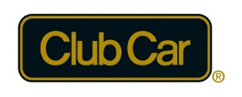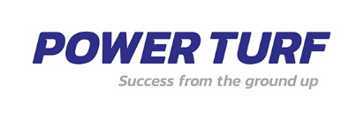



Welcome to the 2023 Club Car GMA NZ Summit
“Partnering beyond the Green”
August 27,28, 2023
Boulcott’s Heritage Golf Club, Lower Hutt
Delegates’ Registration Form


Delegates’ Registration Form
Please return this completed form by email to:
Des Topp – Golf Managers Association of New Zealand
T: +6421392007 E: eo@gmanz.co.nz
GMA NZ/NZPGA PO Box 39 272, Howick, Auckland, 2145

DELEGATE PARTNER
YOUR DETAILS
Title (Mr. / Mrs. / MS etc.)
First name Surname
________________________________________________________________________________________________
Club/Company
Position
Dietary / Special Requests
The Privacy Act 1993 requires that before we can publish your name, address, and any details in the list of delegates provided to sponsors, you must give your consent. Tick here if you DO NOT want your details to appear on a delegate list.
HOW DO WE CONTACT YOU:
Club/ Company__________________________________________________
Postal Address __________________________________________________
Suburb, City & Postcode__________________________________________
Daytime & Mobile Number________________________________________
Email Address___________________________________________________

MY REGISTRATION CATEGORY
Delegate - member Delegate – non-member Delegate partner
Day guest Monday Club Car Dinner Guest
REGISTRATION FEES* DELEGATE DELEGATE
GMA NZ Member (includes Club car Awards D $250.00 + GST
Extra delegate (includes Club Car Awards Dinner ) $250.00 + GST
Summit Club Car dinner guest $120.00 + GST

PAYMENT OPTIONS
Total amount to be charged to my account: $.........................
Option 1: On Invoice: Please forward an invoice to facilitate payment.

Option 2: Direct Credit:
Account Name: Golf Club Managers Association of New Zealand
Account No: 02-0404-0203840-000
Transaction Date: ___________________________ Reference Used:__________________________

Option 3 : Credit Card: I authorise the organiser to debit $ ……………………from my credit card plus a 3% transaction fee.
Card Number:
Card Type:_______________________ Expiry Date: ________________________CSV Number:__________
Name on Card Signature:
ACCOMMODATION:
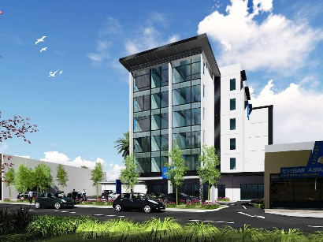
The Sebel Lower Hutt, as the preferred accommodation supplier, provides a 15% dynamic rate code for the conference dates. The 15% dynamic rate code discount can be actioned by Summit delegates by directly booking from our hotel website.

GMA NZ Summit 2023 - Accor Meetings & Events (accorevents.com)

Please note: The room rates are dynamic in nature, 15% discount will be applied to the rates at the time of you making the reservation.

TERMS & CONDITIONS
- All prices are in New Zealand dollars and are exclusive of NZ GST which will be applied at 15%.
- Payment by credit card incurs a 3% card fee.
- Registration will be confirmed in writing, upon receipt of the total payment due.
- Cancellation is required by written notice to the Organiser and will result in the following:
- Prior to 20th July 2023, a full refund on the Registration Fee will be made less an administration fee of NZD $75.00 + GST. After 20th July 2023, no refund will be provided for any / all Registration Fees
- Accommodation is subject to availability and is the delegates responsibility.
- The Host and Organiser reserve the right to alter the programme if required.

