Club Management Association of New Zealand

Newsflash – August 2025

Add to bottom of the link
NZGIC CONFERENCE 2025 – UPDATE WEBSITE WITH LATEST PROGRAMME FILE

PROGRAMME under REGISTER
USE REGISTRATION FILE OPTION RATHER THAN FORM

Need to also add a message

DON’T forget to register for the Whole of Golf Conference along with your Super Pro/Pro Shop Manager/Director of Golf plus your club President/Chair – there’s something for all over the two days of plenary sessions with still more to come.
Early bird registration closes June 27, 2025.Delete
Check out the Conference Programme HERE

Leave in

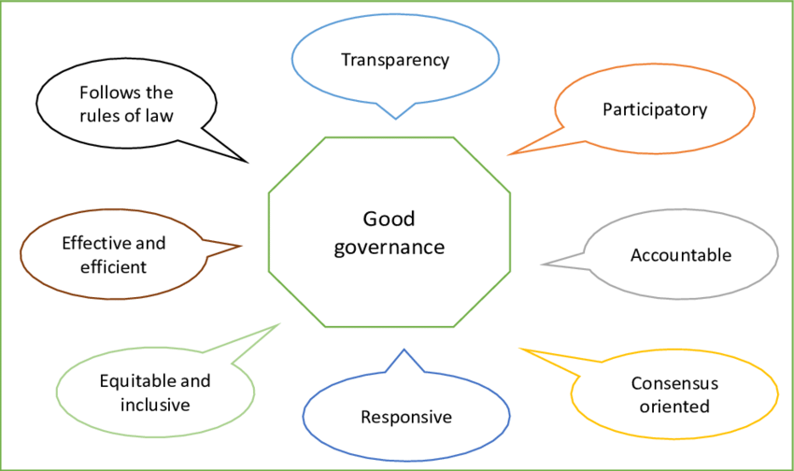
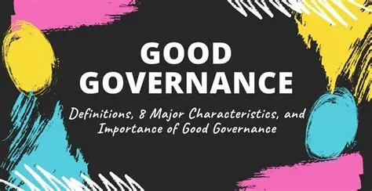
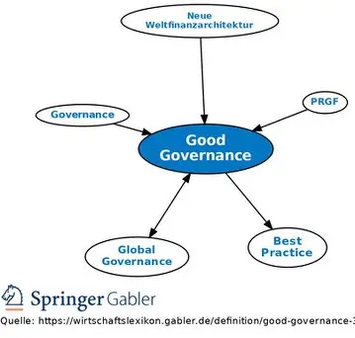
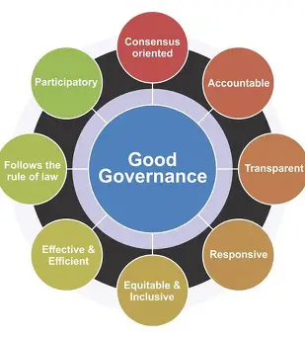
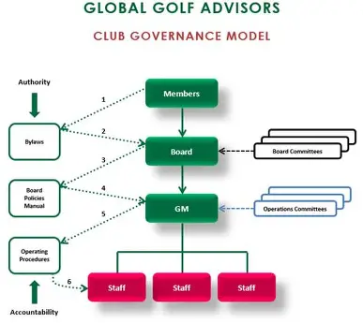
BMI Education programme

Add in

BMI Courses – 2025
BMI Club Management – November 3-7, 2025

Leave the following as is
The curriculum and learning outcomes have been provided by the Club Managers Association of New Zealand and this training course is endorsed by the Club Managers Association of America as part of the educational pathway to the Certified Club Manager (CCM) qualification.
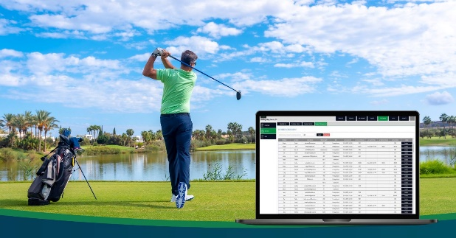

BMI I Club Management Learning Objectives

- Employment Law:
- Lumina Spark
- IT Solutions for Club Managers
- Cybersecurity & Risk Awareness
- Management to Leadership and Delegation: From Good Manager to Effective Leader – Learning Objectives
- Club Governance: Structure, Roles & Responsibilities, and Economic Impact – Learning Objectives
- Accounting Fundamentals and Financial Operations for Club Management – Objectives:
- Club Marketing Solutions
- Club Legal and Legislative Session
- Club Culture and Leadership
- Communication with Members, Your Team and Your Community
- Beyond Buzzwords: Reimagining DEI Through Leadership, Neuroscience, and the Power of Thought”
- Strategic Recruiting
- Staff Communication
For a full description of the Learning Objectives of the BMI Club Management course please click on the LINK

------------------------------------

Add this section in

BMI Food and Beverage Management May 11-15, 2026



BMI Food & Beverage Management provides an in-depth look at food and beverage operations from a management and control perspective.
The five-day program offers a combination of classroom lecture and hands-on learning at various clubs throughout the Auckland area. Attendees will have the opportunity to visit the facilities at the Royal Auckland and Grange Golf Club and the Remuera Golf Club, view and experience the production and tasting facilities at Jacks Coffee and Dilmah tea, participate in a hands-on cooking experience at Main Course Cookery School hosted by Sonya Oyston and learn the art of tapping a keg and pouring a perfect pint compliments of Asahi Beverages.
COURSE:
- Food service marketing |  | Beverage costing
- Kitchen layout and renovation |  | Sanitation and Safety
- Employee diversity |  | Menu engineering applications
- Alcohol awareness | Beverage production: Tea Coffee
- Catering and special events |  |  | Garden to Table” opportunities
Click HERE to view course curriculum

Leave this section as is including the link at the bottom

The Benefits of Continuing Education with CMAA and CMA NZ
Managers who engage in the BMI Career Development Programme enjoy numerous advantages, including:
- Connecting with industry experts.
- Networking with fellow managers from the most innovative and prestigious clubs both nationally and internationally.
- Exploring new ideas to implement in their own clubs.
- Learning from the nation’s top club management educators.
- Visiting and touring other club operations.
- Growing not only as individuals but also as key members of their club’s management team

Click here to view full details of the continuing BMI education programme.

---------------------------------------------------------
BMI Golf Management Course Testimonial
The BMI Golf Management course was an incredible learning experience. Walking top facilities at Tara Iti, Te Arai, Royal Auckland and Grange gave insights you just can't get in classrooms, and hearing directly from key staff was brilliant for understanding operational excellence.
I gained valuable course maintenance knowledge and developed deep respect for their expertise. I also found great retail and customer service ideas to implement at my club, plus networked with like-minded professionals in similar roles. Highly recommend it, especially to golf operations team members.
Nicole Martino CCM
Golf Manager
The Western Australian Golf Club

------------------------------------------------------

_________________________________

Add these next two sections section in and add photos

Add this section in

Strengthening Club Governance: Insights & Actions

Clubs are steadily adopting better governance practices, yet key opportunities remain in strategic planning, risk management, and member communication.
Key Governance Insights
- Strategic Planning: Clubs with documented plans show stronger board oversight, yet many boards lack consistent planning frameworks.
- Member Communication: Education, transparency, and direct communication with members drive higher engagement and governance clarity.
- Risk Management: Most clubs are underprepared for unexpected disruptions, often lacking formal risk and succession plans.
Opportunities for Improvement
Strategic Oversight
- Shift board focus from procedural to strategic leadership.
- Define board roles and committees; offer orientation for new members.
- Use documented planning to support effective delegation and future-focused discussions.
Risk Management
- Develop and implement a formal risk management and succession plan.
- Create a board policy manual to guide decision-making and continuity.
- Ensure strategic planning drives proactive responses to external uncertainties.
Member Communication
- Strengthen transparency by publishing board and committee updates.
- Host governance education sessions and informal member events.
- Appoint board liaisons to encourage dialogue and feedback.

For actionable tools, templates, and best practice resources, consult the Club Management Association of New Zealand at golfmanagers.co.nz under Library/Resources.
__________________________________

Leave this amended section in but shift it to later in the booklet

Club Governance Handbook



To download a copy of the handbook, click on the LINK

--------------------------------------------
Amend this section in

2025 Annual Salary Survey

We ask you to put aside 10 minutes to complete the survey. Note if you have staff on wages and part-time staff please convert earnings to a full year equivalent

Action required
Only 54 clubs have completed the survey!!! We need another 26 replies

Click HERE to complete the survey.

---------------------------------------------------------

Leave this section in including the link

2024 Annual Salary and Wages Survey Results



Action: Click HERE to view summary analysis tiered by ZONE
----------------------------------------------
Amend this section

Club Benchmarking 2024 Report
Golf club benchmarking provides valuable insights into financial performance, strategic planning, cost management, and competitive positioning. By analysing industry trends and best practices, clubs can optimize revenue, enhance member satisfaction, and maintain long-term sustainability.
Thank you to the clubs that provided financial data in support of the CMA NZ 2024 Benchmarking report.
Click HERE to view the report

Action required.
Request a peer-to-peer review of your club’s 2024/2025 Club Benchmarking results with a club of similar size in terms of turnover or member numbers.
Send your request to eo@gmanz.co.nz.

------------------------------------
Leave this section as is
CLUB MANAGEMENT ASSOCIATION OF NEW ZEALAND

Executive Recruitment Service

The Club Management Association of New Zealand (CMA NZ) offers an Executive Recruitment Service to its members at attractive rates. CMA NZ will connect your Club with skilled professionals who are looking for permanent opportunities and streamline the process to ensure that your recruitment needs are met.
Finding the right person for a role is more than just a skills match. Combining many years of club management knowledge and a high-calibre level of member service driven to deliver on your hiring objective, your Club will benefit from CMA NZ personalised talent identification solutions.
The industry specific, end-to-end service, conducted in partnership with selected club board personnel includes:
- Composing Job Descriptions for management positions across the entire golf club sector
- Creating an appointment process timeline
- Managing the vacancy advertising campaign
- Interviewing candidates
- Selecting and managing short lists
- Arranging final interviews
- Providing benchmarked salary packages
- Negotiating and finalising salary packages
- Preparing employment agreements
- Attractive rates for GMA NZ members

For a confidential golf club executive recruitment proposal contact:
Des Topp
Executive Officer
Club Management Association of New Zealand
E: eo@gmanz.co.nz
T: 021 392 007

-----------------------------------------

Job board
Add these jobs in
Management Positions

Royal Auckland and Grange Golf Club
Director of Operations
Auckland
Please HERE to view the advertisement

Royal Auckland and Grange Golf Club
Director of Finance
Auckland
Please HERE to view the advertisement


Canterbury Golf
Marketing and Communications Coordinator
Click HERE to view advertisement
______________________
Add this in – new ad
Golf Operations and Support Role
Click HERE to view advertisement

Canterbury Golf is now recruiting for the position of Golf Operations and Support to continue the great work that has been undertaken in the position over the last decade.
The role requires a combined skillset of astute attention to detail alongside an ability to greet and assist various stakeholders as the first point of contact for the organisation.
This full-time role oversees the administration and management of Canterbury Golf’s Interclub competitions, the District calendar, office Management, and more.

ADD IN

Senior Golf Front Desk & Operations Assistant
Click HERE to view the advertisement

____________________________

ADD IN


Helensville Golf Club
Golf Operations Manager
Click HERE to view advertisement

----------------------------------

Leave this section as is

Board Members 2023/2024
Northern Branch representative  and Chair    Matt Owen - GM Pupuke GC  gm@pupukegolf.co.nz | Bay of Plenty Branch representative    Michael Williams - GM Mt Maunganui GC  michael@mountgolf.co.nz
Waikato Branch representative    Scott Meiklejohn GM Tieke GC  gm@tiekegolf.co.nz | Central Branch representative    Amy Sidford CCM - GM Boulcott’s Heritage Farm GC  admin@boulcottsfarmhgc.co.nz
Northern South Island Branch representative    Mike Hadley - GM Christchurch GC  ce@christchurchgolf.co.nz | Southern South Island Branch representative  Drew Butcher – GM Otago Golf Club  generalmanagerotagoclub.co.nz
Independent representative    Dylan Lindstrom PGA CCM  GM Royal Wellington GC  dylan.lindstrom@royalwellington.com  Central Otago Branch Representative    Anthony O’Brien  GM Jacks Point GC  anthony.obrien@jackspoint.co.nz  Executive Officer    Des Topp  eo@gmanz.co.nz  ADVERTISING  Add in Hadley Management Services advert from November onwards   | Independent representative    Matt Guzik CCM CCE  GM Tara Iti  matt.guzik@taraiti.com

Our partners


IF NOT ALREADY DONE PLEASE ADD THESE LOGOS








