

Food & Beverage Management

May 11 – 15, 2026

Remuera Golf Club

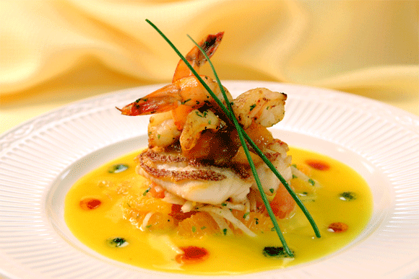

BMI Food & Beverage Management provides an in-depth look at food and beverage operations from a management and control perspective.
The five-day program offers a combination of classroom lecture and hands-on learning at various clubs throughout the Auckland area. Attendees will have the opportunity to visit the facilities at the Royal Auckland and Grange Golf Club and the Remuera Golf Club, view and experience the production and tasting facilities at Jacks Coffee and Dilmah tea, participate in a hands-on cooking experience at Main Course Cookery School hosted by Sonya Oyston and learn the art of tapping a keg and pouring a perfect pint compliments of Asahi Beverages.
COURSE:
- Food service marketing | - Beverage costing
- Kitchen layout and renovation | - Sanitation and Safety
- Employee diversity | - Menu engineering applications
- Alcohol awareness | - Beverage production: Tea Coffee
- Catering and special events | - “Garden to Table” opportunities

Day 1 Monday 11 May 2026 at Remuera Golf Club
8.40 to 8:45 AM | Welcome and Housekeeping
8:45 to 10:15AM | Module 2 and 8  Staff selection/staff training – part 1 | Warren Collett CCM  GM Wairakei GC
10:15 to10:30AM | Break
10:30 to11:30AM | Module 2 and 8  Staff selection/Staff training- part 2 | Warren Collett CCM  Wairakei GC
11:30 to12:30PM | Module 5 Responsible Alcohol Practices | Warren Collett CCM  Wairakei Golf Club
12:30 to 1:15 PM | Lunch
1:15 to 2:15 PM | Module 5  Food and Beverage Legal requirements | Warren Collett CCM  Wairakei Golf Club
2:15 to 3.15 PM | Case Study
3:15 to 3:30 PM | Break
3:30 to 5:00 PM | Module 19  Club Kitchen restaurant design and restoration.  Case study – Remuera Golf Club | Chris Davies CCM  GM Remuera Golf Club  John Durkin  Abri Architects
 | Evening Free
Day 2 Tuesday 12 May 2026 at Remuera Golf Club
8:30 to 10:15 AM | Module 10 & 13  Food costings/ Menu Planning and Engineering | Sirpa Gunn  Restaurant Association Auckland
10:15 to10:30AM | Break
10:30 to11:30AM | Module 6  Labour Cost Control | Sirpa Gunn  Restaurant Association Auckland
11.30 to 12.00PM | Module 20  Club/F&B Department Personnel Organization Structure | Chris Davies CCM  GM  Remuera GC
12:15 to 1:00PM | Lunch
1:00 to 1.45PM | Module 3  Hands on F&B Marketing Project  Case study | Chris Davies CCM  GM  Remuera GC
1.45 to 3.00PM | Case Study
3.00 to  3.15 PM | Break
3.15 to  4.00 PM | Case Study
4.00PM | Evening free

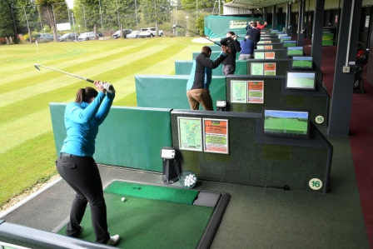

Day 3 Wednesday 13 May 2026 at Remuera Golf Club
8:30 to 10:15 AM | Modules ! &11  Cost of Goods Sold Mastery | Liz Perkins  Perkins Coaching
10:15 to 10:30 AM | Break
10:30 to 11:30 AM | Module 16  Food and Beverage financial planning  A practical lesson on how to set targets for your COGS, wages and sales. Decide on a pricing strategy and communicate your goals to your team.  Please bring along your current P&L to include detailed Food and Beverage report. | Liz Perkins  Perkins Coaching
11.30 -12.30PM | Module 19  Design a front of house renovation based on your customer profiles | Liz Perkins  Perkins Coaching
12.30 to 1.30 PM | Lunch
1.30 to 2.30 PM | Module 18  Annual Event Strategy | Liz Perkins  Perkins Coaching  TBC
2.30 PM | Transfer to Jacks Coffee/Dilmah Tea
2:35 to 4.30 PM | Module 9  Coffee and Tea Masterclass  Maximize your profits from Coffee and Tea Education and Tour | Jacks Coffee – David Burton  Dilmah Tea – John Burton
4.30 PM | Transfer back to Remuera Golf Club
 | Evening free

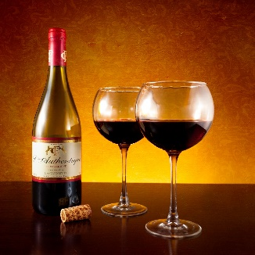

Day 4 – Thursday 14 May 2026 at Royal Auckland and Grange Golf Club
8:30 to 10:15 AM | Module 21  Club Dining promotions. | Ed Chapman  PGA CCM  Royal Auckland and Grange Golf Club
10:15 to 10:30 AM | Break
10:30 to 11:30 AM | Module 12  Asahi Beer Masterclass  Use AI to design a beer menu for an average size club | Jake Ross  Jessica Harwood  Asahi NZ
11:30 to 2:00 PM | Site visit and lunch  Royal Auckland and Grange Golf Club | Ed Chapman PGA CCM  Royal Auckland and Grange Golf Club
2.30 - 3.30PM | Transfer to the Main Course Cookery School  Module 22  Food trends | Sonya Oyston  The Main Course
3.30 – 4.30PM | Main Course Cookery School  Module 17  Beer and Wine Appreciation Class | Sonya Oyston  The Main Course
4.30 – 8.30PM | Main Course Cookery School  Module 14  Cool and Confident – Basic cooking skills | Sonya Oyston  The Main Course

Day 5 Friday 15 May 2026 at Remuera Golf Club
8:45 to 9:45 AM | Module 4  Service Management – a la carte. | Vijay Bhatia Restaurant Association Auckland
9:45 to 10:00 AM | Break
10.00 to 11.00AM | Module 7  Service Management – Banquets | Vijay Bhatia Restaurant Association Auckland
11:00 to 12:00 PM | Module 23  Technological advances in F&B Management | Chris Davies CCM  GM Remuera GC
12:00 to 12:45 PM | Lunch
12.45 to 2.00  PM | Module 25  Case study presentations
2.00pm | Course close

BMI FOOD & BEVERAGE MANAGEMENT

REGISTRATION FORM

Name:…………………………………….
Golf Managers Assn Member: Yes/No (please circle)
Club:………………………………………
Address:………………………………….
Email Address:……………………………
Phone number:…………………………..
Please register me for BMI Food & Beverage Management
Check to register:

______________________________________________________________
REGISTRATION INFORMATION:
WHEN: | May 11 -15, 2026
WHERE: | Remuera Golf Club, Auckland
COST: | Early bird - $2500.00 + GST  Non – GMANZ Members – add $150.00+ GST
REQUIREMENTS: | Accommodation is to be arranged by the attendee.  GMANZ is happy to provide advice on this.
CONTACT: For all enquiries and to register please email:eo@gmanz.co.nz

BMI FOOD & BEVERAGE MANAGEMENT
Modules Listing
Module 1 | Cost-Volume-Profit Analysis – Calculating F&B breakeven
Module 2 | Food & Beverage Staff Selection
Module 3 | Hands-on F&B Marketing Project
Module 4 | Service Management a la carte
Module 5 | Food &Beverage Legal Applications/ Responsible Alcohol Practices
Module 6 | Labour Cost Control
Module 7 | Service Management – Banquets
Module 8 | Staff Training
Module 9 | Jacks Coffee/Dilmah Tea Master class
Module 10 | Food Costs
Module 11 | Cost of Goods Mastery
Module 12 | Beverage Management/Beer Master class
Module 13 | Menu planning/Menu engineering
Module 14 | Hands on Food Preparation/Hands on Cooking /Dinner presentation/Class dinner
Module 15 | Cocktails Programme
Module 16 | Food & Beverage Financial planning
Module 17 | Beer and Wine Education master class
Module 18 | Annual Event Strategy – Case study
Module 19 | Part 1 Design, Construction and Equipment purchase programme for a new kitchen  Part 2 Design a front of house renovation based on your customer profiles
Module 20 | F&B Department Organization - Panel discussion/Workshop
Module 21 | Club Dining Promotions – Special Events “Great Ideas”
Module 22 | Food Trends
Module 23 | Technological advances in F&B Management
Module 25 | Case study presentations

BMI FOOD & BEVERAGE MANAGEMENT
Course structure

Module 22 - Food trends  Learn how the Food & Beverage experience plays a vital role and is a key to success in a Club environment. | Module 6 - Labour cost control  Module 10- Food costing  Module 11 - Beverage costing  Learn costings breakdown, margins and how to turn your bar/café into a profitable operation in conjunction with your team or contract caterer.
Module 11 – Cost of Goods Mastery  Discover how to fine-tune your venue’s cost of goods with an effective stock control system. Reduce waste and boost your bottom line.  Module 16 – Food & Beverage financial planning  A practical lesson on how to set targets for your COGS, wages and sales. Decide on a pricing strategy and communicate your goals to your team.  Please bring along your current P&L report. | Module 4 - Service Management a la carte  Module 7 Service management – banquets/functions  Effective plate presentation and standards with tools and experience.
Module 13 -Menu planning/Menu Engineering  Key elements of Menu Engineering & Design focusing on local produce & provenance to increase your sales and get the feel-good factor. | Module 19  Part 1  Kitchen design, construction, and equipment  Some first-hand examples of proper kitchen designs for optimum efficiency  Part 2  Front of House design, construction, and fitout  A look at a recent front of house renovation that was designed using the customers’ profiles.
Module 14 – Cookery School Masterclass  A practical hands experience on preparing a menu within a large kitchen and understanding the pressures of the kitchen environment. | Module 2- Food & Beverage Staff Selection  Module – 20 - Food & Beverage staff selection  How to get buy in from your team to deliver a higher standard of service at your club
Module 5 – Food and Beverage Legal applications  HACCP Legislation for the Club Manager and how to run a compliant kitchen. | Module 18 – Annual Events Strategy  Learn how to plan your events calendar and design a customer journey for each different event you host.
Module 17 – Beer and Wine Menu Design and construction  Getting the most from the club’s Beer and Wine List, educating your team to upsell from House Wine! | Module - 9 - Coffee and Tea Masterclass  Achieve more sales and margin from selling a quality coffee and tea product to your members.
Module 3 -Hands on F&B Marketing Project  Module 21 – Club Dining promotions  Marketing and communicating to your membership your enhanced food & beverage offering. | Module 8 – Staff Training  Manage and analyse feedback fairly to constantly drive forward your product and get results.
Module 12 – Beer Masterclass  Learn about a Suppliers(Asahi) product range  Design a beer menu for two new golf club from scratch using AI | Module 19  Part 1  Kitchen design, construction, and equipment  Some first-hand examples of proper kitchen designs for optimum efficiency  Part 2  Design a front of house renovation based on your customer profiles
Module 20 – Technological advances
Learn about modern analytical advances to improve your food and beverage operation

Food & Beverage Management

Class of 2026

Case Study Teams
Blue Team | Red Team | Green Team

Food & Beverage Management

Presenters List

Liz Perkins Dip Hosp Management
Hospitality Business Coach
Perkins Coaching
With a background as a restaurant owner Liz is passionate about people and business. Business ownership is challenging and can be incredibly rewarding. In an industry that demands the best we must apply best practices to every element of our businesses to create and sustain profitable venues.
Liz provides outstanding hospitality business education for owners and employees and encourages meaningful action and follow through resulting in improved profits and personal development.
______________________________



Sirpa Gunn MMgt , Dip Hospitality Mgt.
Hospitality Consultant and Adviser
Hospitality Advice

Sirpa began her hospitality career in Switzerland studying at the Hotel Institute Montreux and went on to complete a Graduate Diploma in Tourism at the University of Otago and a Master of Management at Massey University in NZ.

Sirpa’s hospitality work experience spans 15 years and includes working as a Management Consultant and Advisor in the Hospitality field, in function and event management, hotels, restaurants and cafes and wineries. Sirpa is based in Auckland and works internationally. Sirpa has a special interest in Pacific Island Tourism strategies.

______________________________


Vijay Bhatia,
Restaurant Association,
Professional Development Trainer

Vijay is an accomplished F & B Service manager having worked internationally in hotels and restaurants across India, Dubai, and New Zealand, which has been his home for the last 18 years. He is passionate about hospitality in general, and hospitality industry training in particular. He enjoys connecting with aspirational individuals wanting to make their careers in this industry. Training is his way of sharing his knowledge, passion and experiences within this sector. He enjoys using his skill set to motivate, challenge and encourage people wanting to learn and experience what working in this industry could mean for them.
______________________________



Main Course is New Zealand’s cooking event leader.
The original. The best.

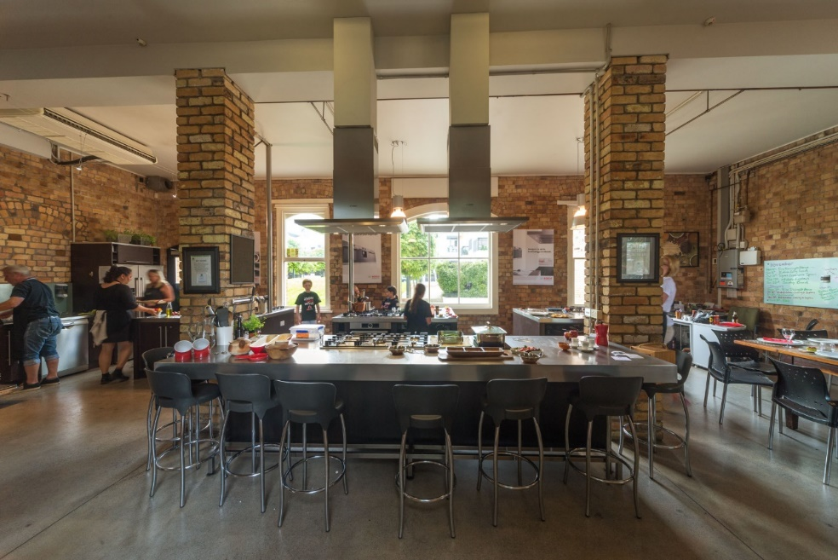

Sitting inside the iconic brick Auckland Gas Building across from Victoria Park, Main Course has set the standard for cooking events since 2003. Our wonderful space is light filled and funky, blending the original exposed brickwork with state-of-the-art polished stainless-steel benches and the very latest Bosch equipment.
We also understand that everyone is here to have fun, so while the techniques and lessons are based around many years of kitchen experience, we make sure that even the most amateur cook feels comfortable.
When you walk away, we guarantee you’ll have the skills to create a wicked dish or two at Main Course and will never be afraid of cooking for your Mother-in-law or catering your own party again!
You can find us at 20 Beaumont Street. There is parking directly outside the building and there is a carpark right next door in the Victory Convention Centre

VISIT TO ‘THE MAIN COURSE” COOKERY SCHOOL

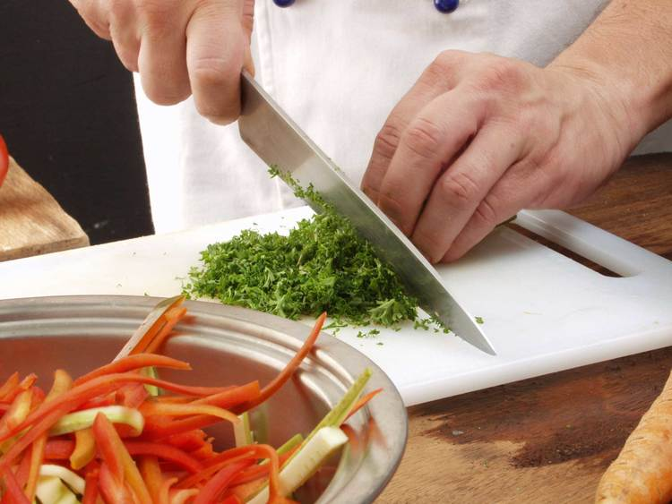

Cool & Confident Basic Skills
Gain practical experience in the kitchen with our hands-on cooking class. Start with the basics and create three delicious dishes. Learn essential techniques such as heat management, knife skills, timing, temperature, and menu planning. We'll also provide helpful advice on purchasing, cooking for different occasions, and avoiding common mistakes. With plenty of laughter, this class is perfect for nervous beginners. The class is fully hands-on and lasts around 2.5 hours, ending with a relaxed meal and the chance to socialize over New Zealand's finest wine and beer.
Enjoy!

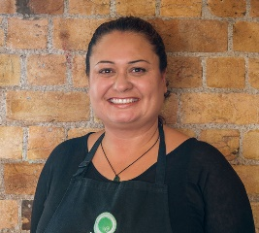

Sonya Oyston
Director
The Main Course
Sonya learnt her kitchen craft in Switzerland and, like most chefs, took her culinary skills around the world. After a stint in Europe and the UK, Sonya made her way to Asia where she immersed herself in new cultures and new flavours. She also passed on her knowledge and passion, training chefs and service staff. She returned to New Zealand in time for the millennium celebrations and continued her training work in Auckland.
TOP TIP: “The best way to get better in the kitchen is to experiment - try unusual ingredients and recipes from all over the world!”
MY FAVOURITE DISH: Anything with Chillies :-)
FAVOURITE INGREDIENT: Chillies

Beer technology and training masterclass - supported by Asahi.


Asahi started brewing beer in 1889. Almost a century later, in 1987, a new standard in Japanese brewing was set with the launch of Asahi Super Dry. Asahi Super Dry has since continued to grow in popularity, delivering clean, crisp, refreshing “Karakuchi” (dry) flavours to beer aficionados the world over.

ASAHI SUPERDRY

Through innovative Japanese brewing techniques, Asahi Super Dry has achieved a delicate, yet rich, full-flavoured body with a refreshing, dry aftertaste. The lager is brewed using the finest quality yeast, malt, hops, maize & rice. Firmly focused on taste preferences, Asahi is brewed to perfectly compliment any meal while retaining its refreshing quality.
Japanese beer.

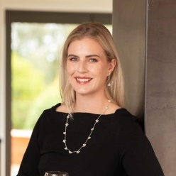
Jake Ross and Jessica Harwood
Business Development Executives
Asahi Beverages
Learn about the basics of beer lines maintenance, the Asahi Product range and how to perfect the “Perfect Pour”.
______________________________

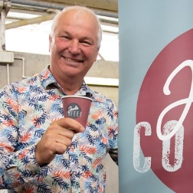
David Burton/Jack Burton
Managing Director, Jacks Coffee
Jack's Coffee delivers freshly roasted coffee and hot chocolate directly to your door. Named after the founder's father, John Edward Ledgard Burton, Jack's Coffee Company is passionate about the knowledge, buying, and tasting of coffee and tea. David Burton, one of the fathers of the New Zealand coffee industry, co-founded Burton Hollis to supply the hospitality industry with coffee beans for 16 years. After selling Burton Hollis, David restarted from scratch, roasting and delivering coffee straight from the roaster to customers' doors. David aims to bring back the ceremony of drinking coffee and help customers get the most out of their drink by sharing his brewing knowledge with each delivery.
Try it for yourself - you won't be disappointed!
______________________________

Chris Davies CCM
General Manager – Wainui Golf Club, Past President - Golf Managers Association of New Zealand

At the age of 11, Chris developed a love for golf. He pursued a career in sports and earned a BA Hons Leisure Management Degree in 1994. In 1995, he secured his first role as a Golf Manager with a Local Authority in North Wales. After four years, he became the Club Secretary of Sheringham Golf Club (Norfolk) and in 2002 accepted the position of General Manager at Ferndown Golf Club (Dorset). Throughout his tenure in the UK, Chris was actively involved with the GCMA (Golf Club Managers Association UK).
In 2007, Chris migrated to New Zealand with his family and served as the General Manager of Remuera Golf Club, starting in 2008. His passion for golf and its future led him to be voted onto the GMA NZ Executive in 2011. There, he was responsible for reviewing the Education Portfolio and professional development, which resulted in GMA NZ partnering with CMAA to offer the internationally recognised BMI programme in New Zealand.
From 2017 until 2021, Chris served as the President of GMA NZ. In February 2022, he graduated with his CCM credentials.

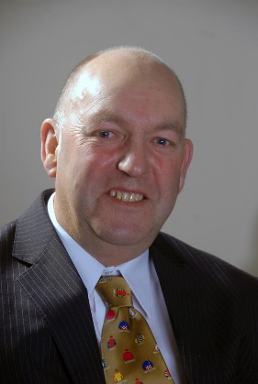

Warren Collett CCM
General Manager – Operations
Wairakei Golf + Sanctuary
For nearly half a century, Warren has been involved in the management of golf. He began his administrative career as a volunteer at Stewart Alexander, where he held every Committee position in the early days. In 1998, Warren accepted the position of General Manager at Lochiel Golf Club and remained there until 2007 when he moved to Far North Queensland to assume the same role at Half Moon Bay Golf Club in Cairns.
However, Warren was enticed back to New Zealand in 2008 to take up a crucial position at the North Shore Golf Club where he served for nine years before relocating to Manawatu Golf Club, where he worked until 2021. Although Warren intended to retire, he became involved in establishing the Tieke Golf Estate, which he successfully opened.
Later, Warren received a new opportunity as the General Manager - Operations at Wairakei Golf & Sanctuary, where he currently works. Warren's outstanding leadership skills earned him the title of President of the National GMANZ Executive. In 2021, he was awarded the Club Manager of the Year and recognized as a Life Member of GMANZ. Lastly, Warren graduated CCM in 2019.

Cancellation policy – BMI Educational Courses

- Candidates for BMI educational courses are required to inform the Golf Managers Association Executive Officer eo@gmanz.co.nz as soon as possible if they wish to cancel their participation in a BMI Course.
- Cancellation will only become effective upon receipt of written notice from the candidate (email notices are acceptable).
- Cancellation by a candidate 30 days from start of course proper - 50% refund is applicable.
- Consideration of a full refund for a cancellation due to exceptional circumstances will be considered by the Board of the GMANZ.
- Any related personal expenses incurred by the candidate such as air travel, accommodation etc. is the responsibility of the candidate.
Refund policy BMI Educational Courses
1. In the event of a cancellation, a candidate may request any refund due to them to be applied to the cost of future BMI courses.

Des Topp
Executive Officer
May 1 2025

Case study
BMI Food and Beverage Management Course

Motunau Golf Club

Objectives:

Working within your groups at the completion of the case study, each person within your group should be able to:

Identify, discuss and provide recommendations to the Motunau Golf Club board for the three of the five important issues identified in the study.

Instructions for this Case Study

Work in your groups to provide recommendations across the issues. Allocate issues to individuals within the group, so 3 of the 5 issues are covered.
Your group has to assume it has been hired as a consultant by the club’s board to analyse the various issues raised.
Your group will provide the board with ideas and prioritized recommendations about issues identified. Unlike many consultants, you have to take a vested stake in the matter, since it is likely the board will look to appoint a new General Manager from within your group. The board will consider all recommendations and perhaps select one of you to carry out the plans. Therefore, your advice must be well thought out on how to implement the recommendations.

Links to descriptive files are available to research subject matters.

The Motunau Golf Club issues present participants with the opportunity to consider a variety of situations similar to what a general manager would face at an actual club.

For individual CMAA BMI assessment purposes each member of the group is to provide:
- a one-page written recommendation on one of the 3 issues selected by your group.
Your group is to appoint a spokesperson to provide:
- a short 2-minute verbal summary presentation on 3 issues selected by your group.
NB Groups will need to cover only 3 of the 5 issues.

BMI Food and Beverage Management Course
Case study

The Motunau Golf Club, formed in 1923, is a challenging links style, member-based golf course situated 30 kilometres north of Christchurch. It has near on 1000 members with an 80% male/ 20% female split.
The clubhouse built in 1952 is on two levels with male and female locker rooms and pro shop on the ground floor and lounge bar and café and kitchen facilities on the first floor. Noisy interruptions from club members on Friday and Saturday nights are a real problem along with having no passenger lift to accommodate the residents of a nearby retirement village. It is conceded that that the clubhouse is dated and needs major renovation to the kitchen, including an upgrade of cooking equipment and new lounge furniture and the installation of bifold doors and a lift to service the lounge area so that private functions can be run separately from club activities.
Estimated cost $1M.

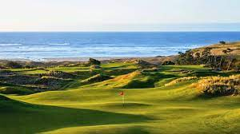
Motunau Golf Club
Exercise 1.
Prepare a short presentation on how, as the Motunau Golf Club General Manager, you would progress the design and installation of a revamped kitchen and lounge area, to have the estimated cost included in the clubs’ next CAPEX budget and for the project to be signed off by the board and then put before and approved by members at the upcoming AGM.
Reference:
Module 19 Kitchen design, construction, and equipment

The club has decided to run its bar and café in-house. The bar is profitable, but the café consistently turns in a deficit which is of major concern for the board. Stock management and , rostering processes along with excessive wastage and a lack of satisfactory costings and POS systems result in less than satisfactory gross profit margins being attained. Peer to peer benchmarking comparing the clubs’ results with those attained by clubs of comparable size confirms the areas of concern. There is also an unconfirmed suspicion that staff are responsible for cash and stock losses.



Exercise 2
Give a short presentation on how, as the Motunau Golf Club General Manager, you would improve Café margins. Click on the link to see how the Club is currently performing in a peer-to-peer benchmarking review of café income and expenditure and margins compared to other clubs of similar style. Motunau Golf Club is club 3.
https://www.golfmanagers.co.nz/assets/_site_/downloads/Motunau_Golf_Club.xlsx
In addition, give an outline of what measures could be used to confirm actual stock and cash losses that have been occurring and what new systems need to be implemented to minimize the risk of the losses apparently due to staff.
References:
Module 1 CVP Analysis
Module 11 End to end Stock Management

The club is desperately trying to engage with the forecasted 10,000 residents of a new housing development 2kms to the north of the course to generate, apart from new memberships, improved casual cabinet food offerings and casual dining opportunities. Progress has been less that satisfactory to date with many adverse comments about the current cabinet food offering and menu perceived as dated, poor café service, tardy dress standards and the unfriendly nature of the staff.

Exercise 3
Prepare a short presentation on how you would improve the menu to meet demand and how you would address the service and dress standards shortfalls.

References:
Module 4 Service Management a la carte
Module 22 Food trends



The club has major staffing issues with a long-standing organisational structure not helping. For some reason the chef, who performs poorly and consistently does not meet the KPI’s set for the position, reports directly to the chair ( a personal friend) and attends and produces financial reports to Board Meetings to the annoyance of the General Manager to whom he reports. The rest of the Board has raised concerns about this and also noted the salary paid to the chef is in excess of that paid to the General Manager and well in excess of recent published industry standards.
Exercise 4
Prepare a recommendation on how the board could solve this touchy and inflammable employment issue.
References:
Modules 2 and 8.
Module 20 Food and Beverage staff selection.

The revamped kitchen and club house will allow the club the opportunity to generate new corporate type business by hiring the clubhouse out for weddings and corporate style functions such as product launches, conferences and forums. The club’s centenary planned for next year is seen as the ideal time to launch the updated facilities.

Exercise 5
Prepare a marketing plan on how you would promote the facility to host the Centenary. Also identify future markets. Include your thoughts on the importance of separate branding for the F&B facility.

References:
Module 3 Hands-on F&B Marketing
To access the file, click here
Module 18 Special events calendar strategy

